**SQL PROJECT**

Blogging platform



Aim of the project:

The aim of the Blogging Platform project is to create a database-driven web application that facilitates content management for blog posts, author profiles, and user engagement through comments. This project serves as a practical example for learning and applying database design principles and SQL queries in the context of a blogging platform.

Objective of project:

The objective of the Blogging Platform project is to develop a database-driven web application that enables users to publish and manage blog posts, authors, and comments, while providing a practical environment for learning and practicing database design principles and SQL skills.

Introduction:

The Blogging Platform project is designed for creating, managing, and interacting with blog content. Users can publish and explore posts, view author profiles, and engage in discussions through comments. This project serves as an educational tool, allowing individuals to learn and practice database design principles and SQL skills in the context of a dynamic blogging environment.

Understanding the Schema of this project

|  |
| --- |
| Posts |
| Post ID (PK) |
| Title |
| Content |
| author |
| Publication D |
| category |

|  |
| --- |
| authors |
| Author ID (PK) |
| First name |
| Last name |
| email |
| bio |

|  |
| --- |
| comments |
| CommentID(PK) |
| Post Id (FK) |
| author |
| Comment date |
| Comment text |

## Top of Form

Let us begin with the Analysis

Q.1 How to describe table post from database blogging_platfrom?

* Syntax: Describe posts; or desc posts;

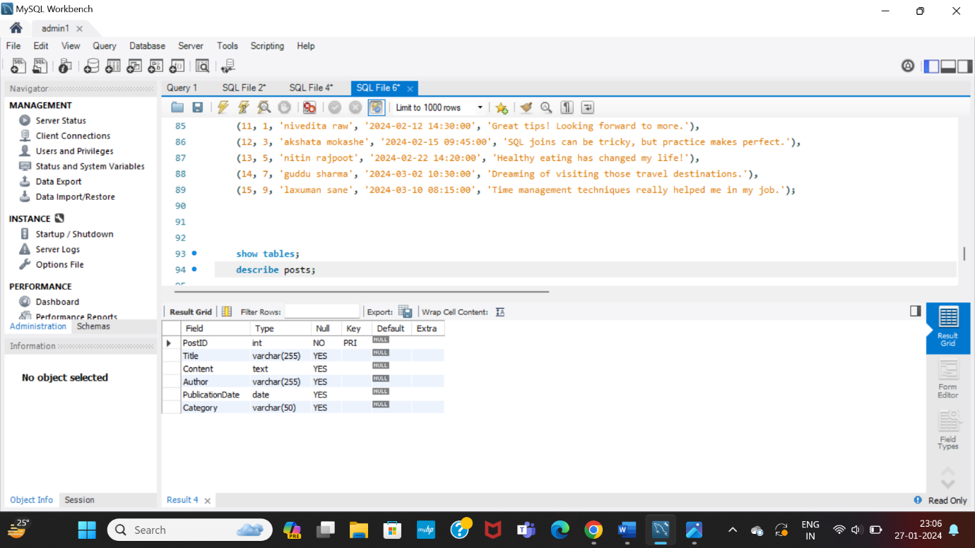

Q.2 How to describe table authors from database Blogging_platfrom?

* Syntax:-Describe authors; or desc authors;

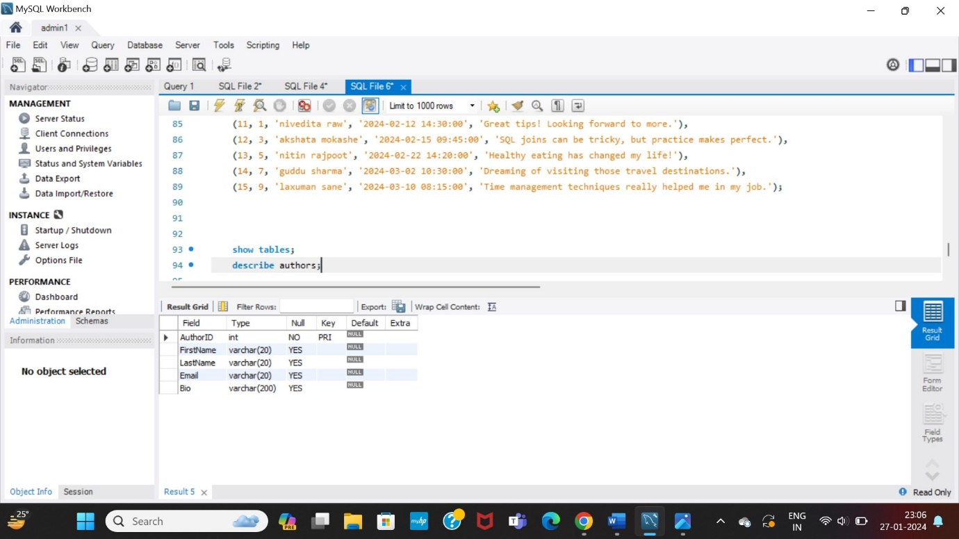

Q.3 How to describe table comments from Blogging_platfrom?

* Syntax:-Describe authors; or desc authors;

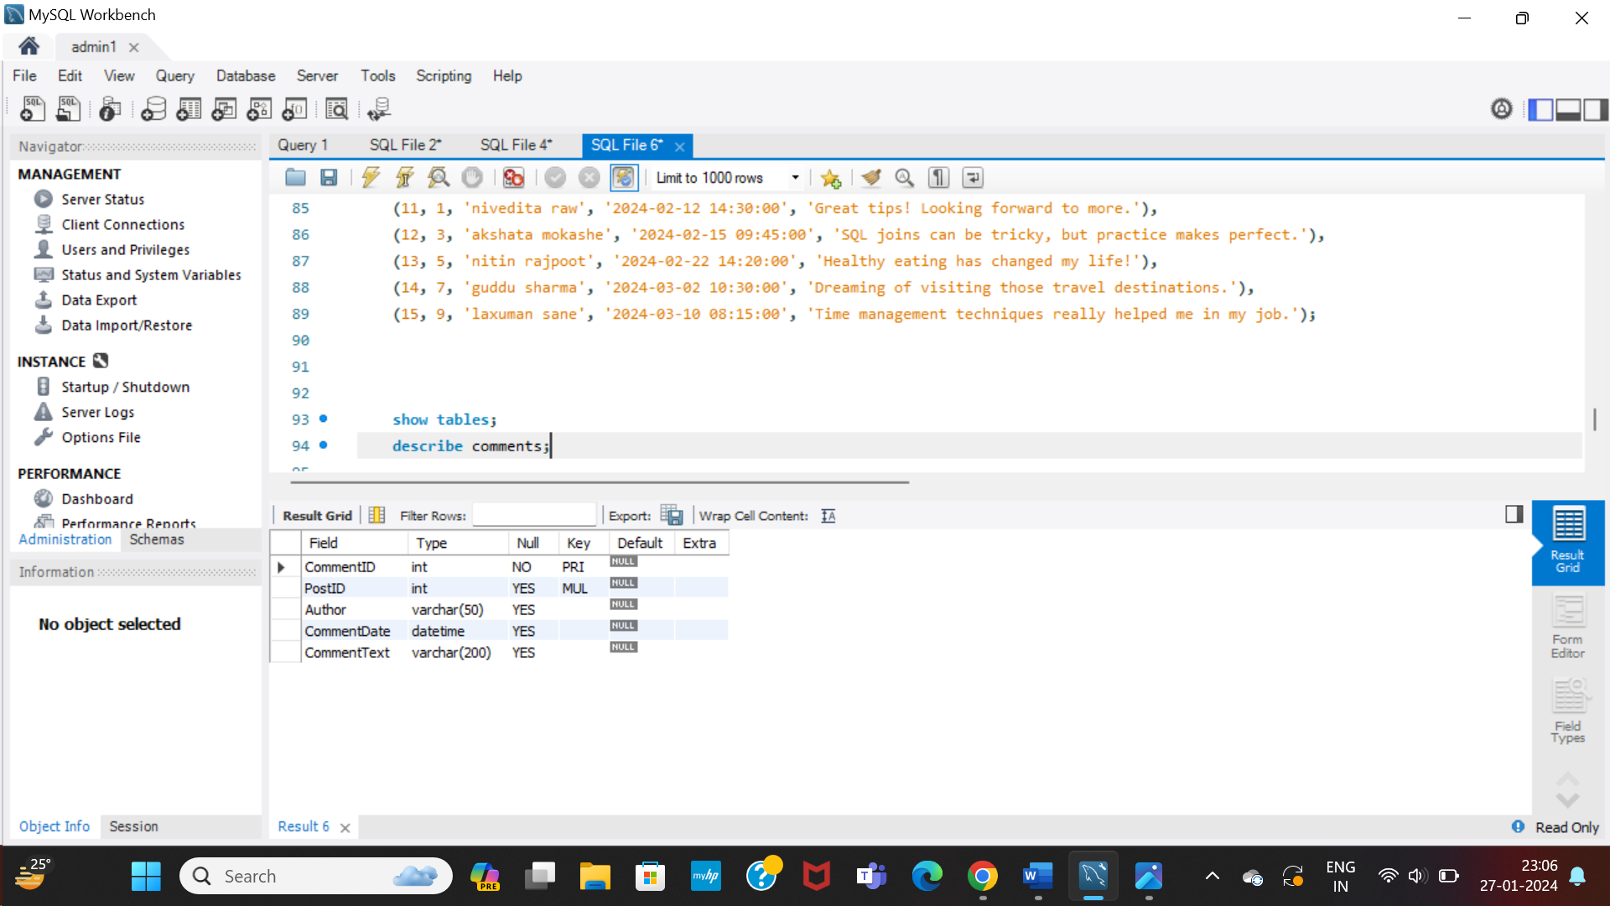

Q.4 How to select entire table posts?

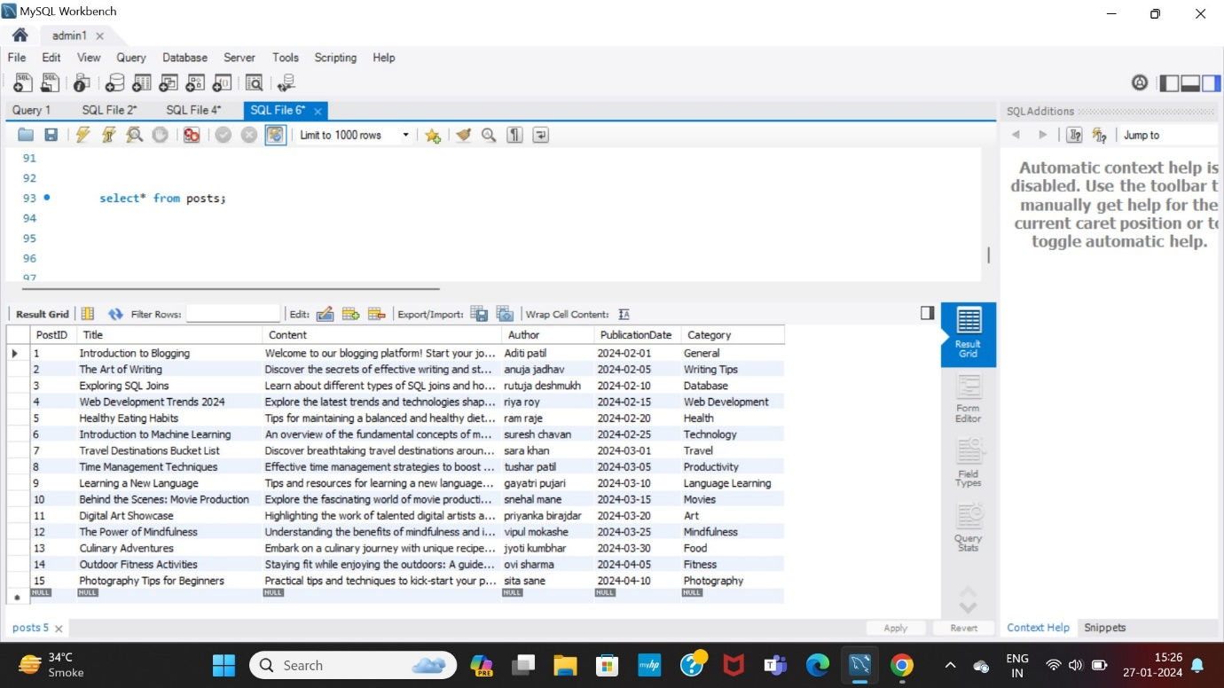

Q.5 How to see entire data in table authors?

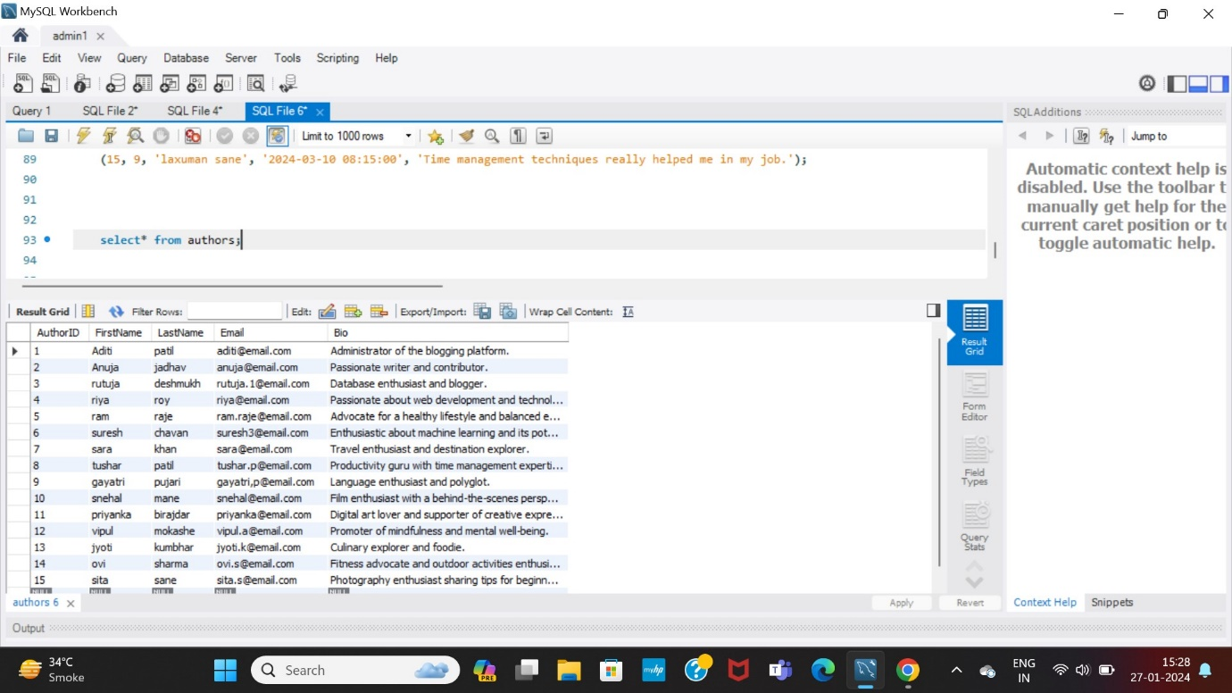

Q.6 How to see entire data in table comments?

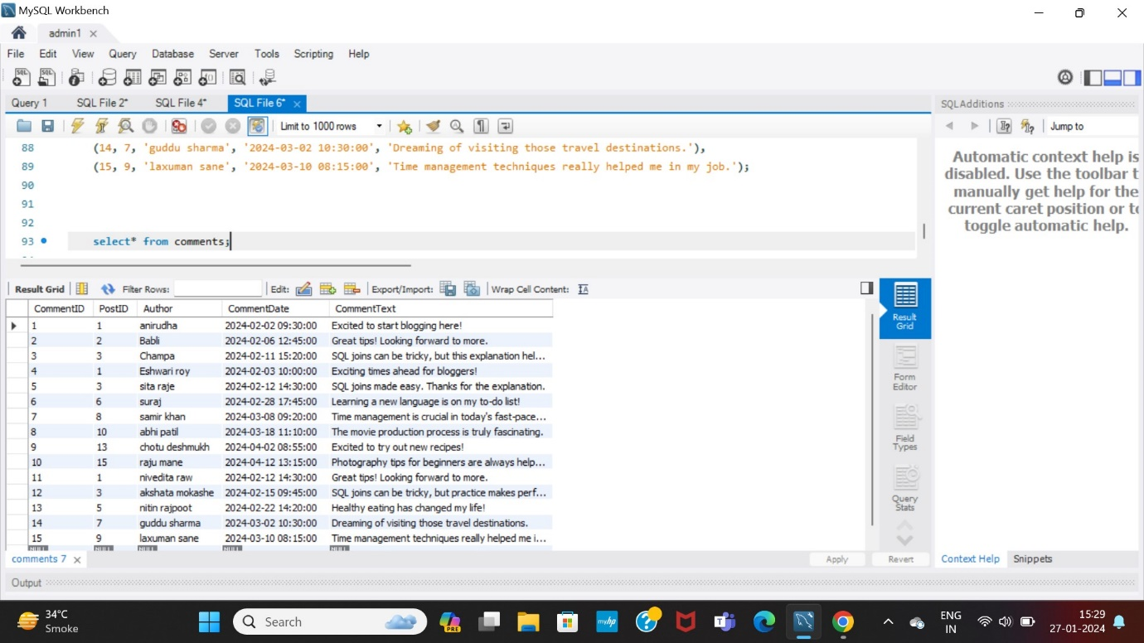

Q.7 How to fetch matching rows from table posts and comments?

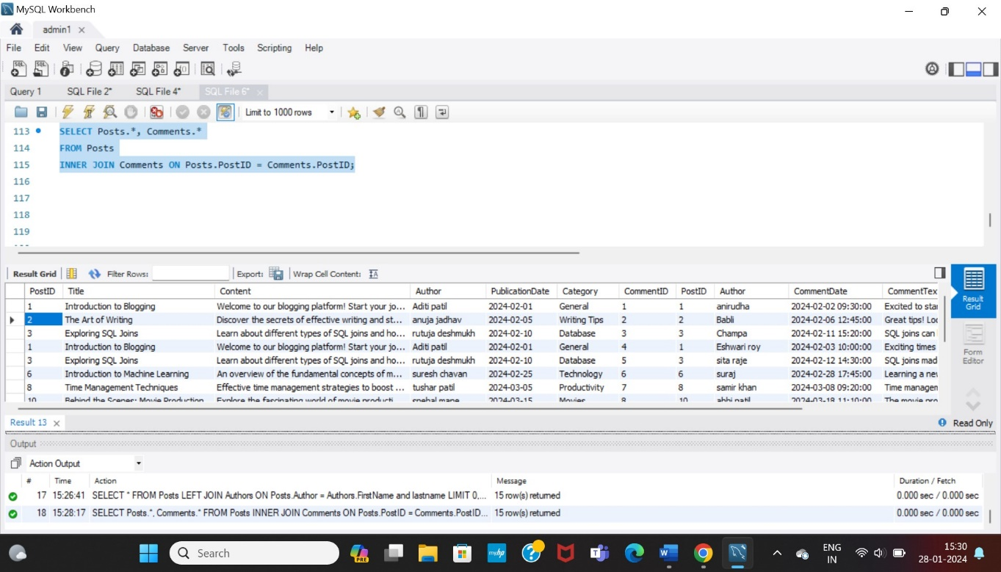

Q.8 How to fetch matching rows and entire rows from left side of table from table posts and comments?

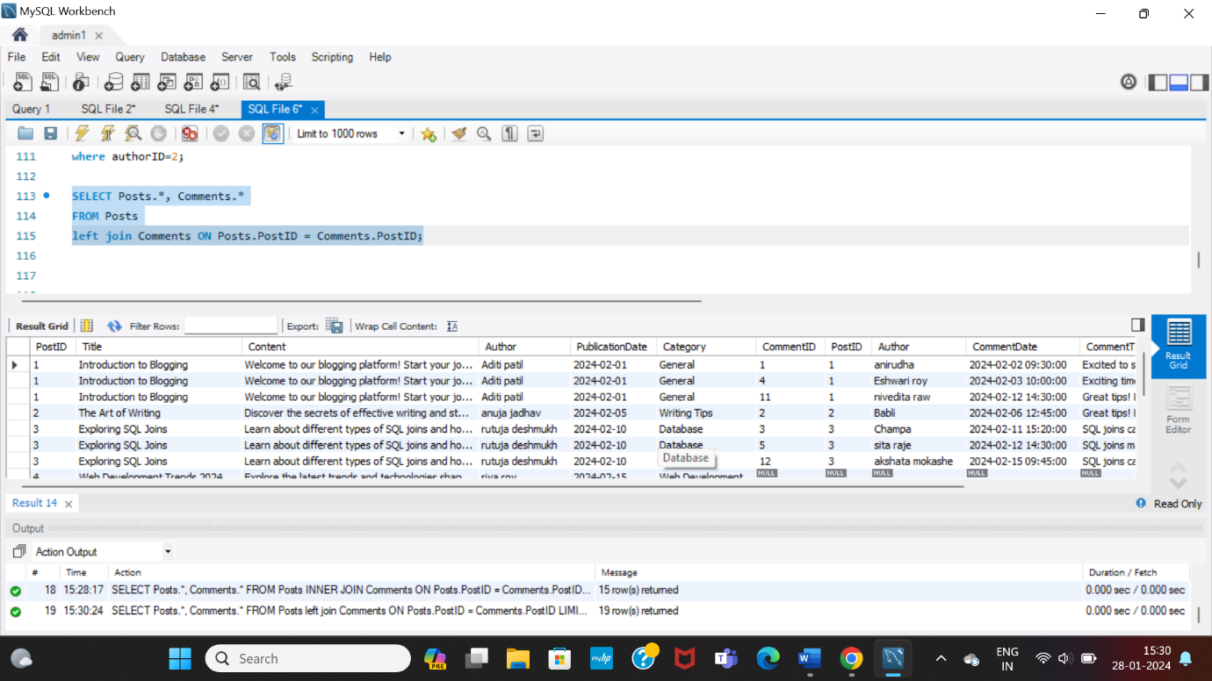

Q.9 How to fetch matching rows and entire rows from right side of table from table posts and comments?

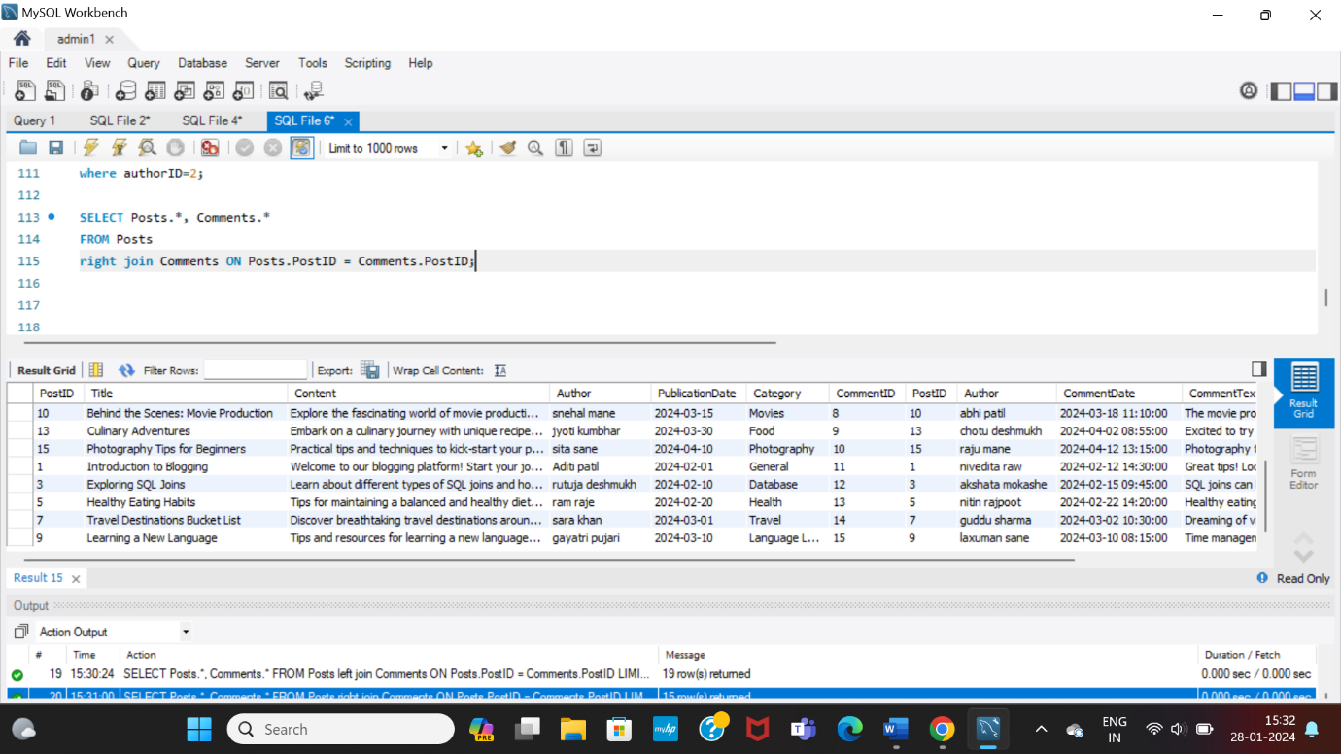

Q.10 How to perform cross join in table posts and comments?

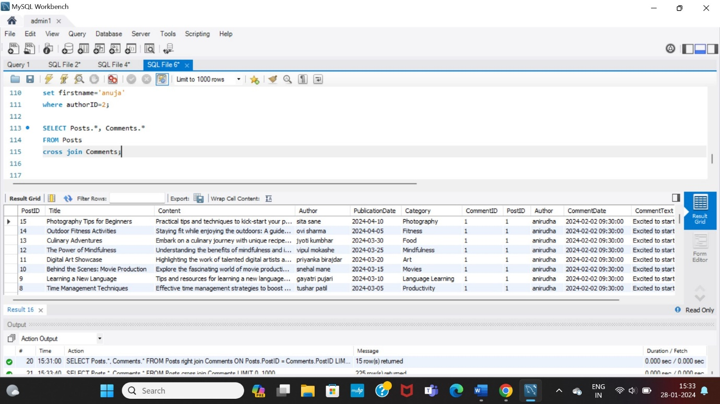

Q.11 How to fetch posts category wise technology and travel by using IN operator?

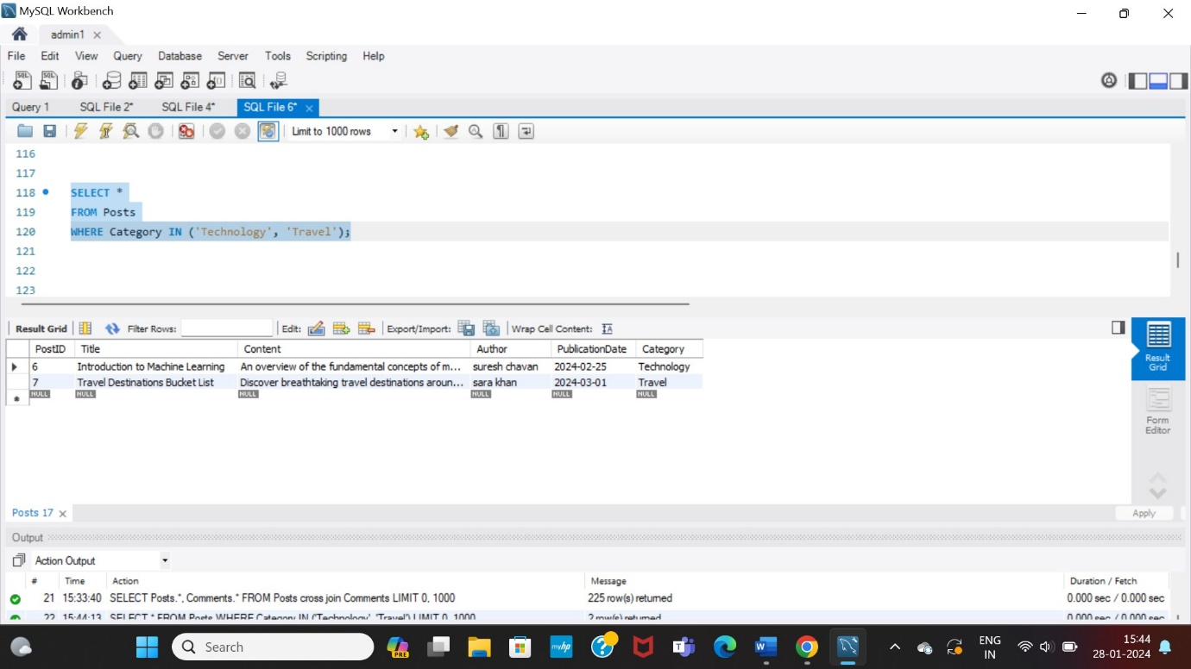

Q.12 How to fetch ID 1 and 2 by using between operator?

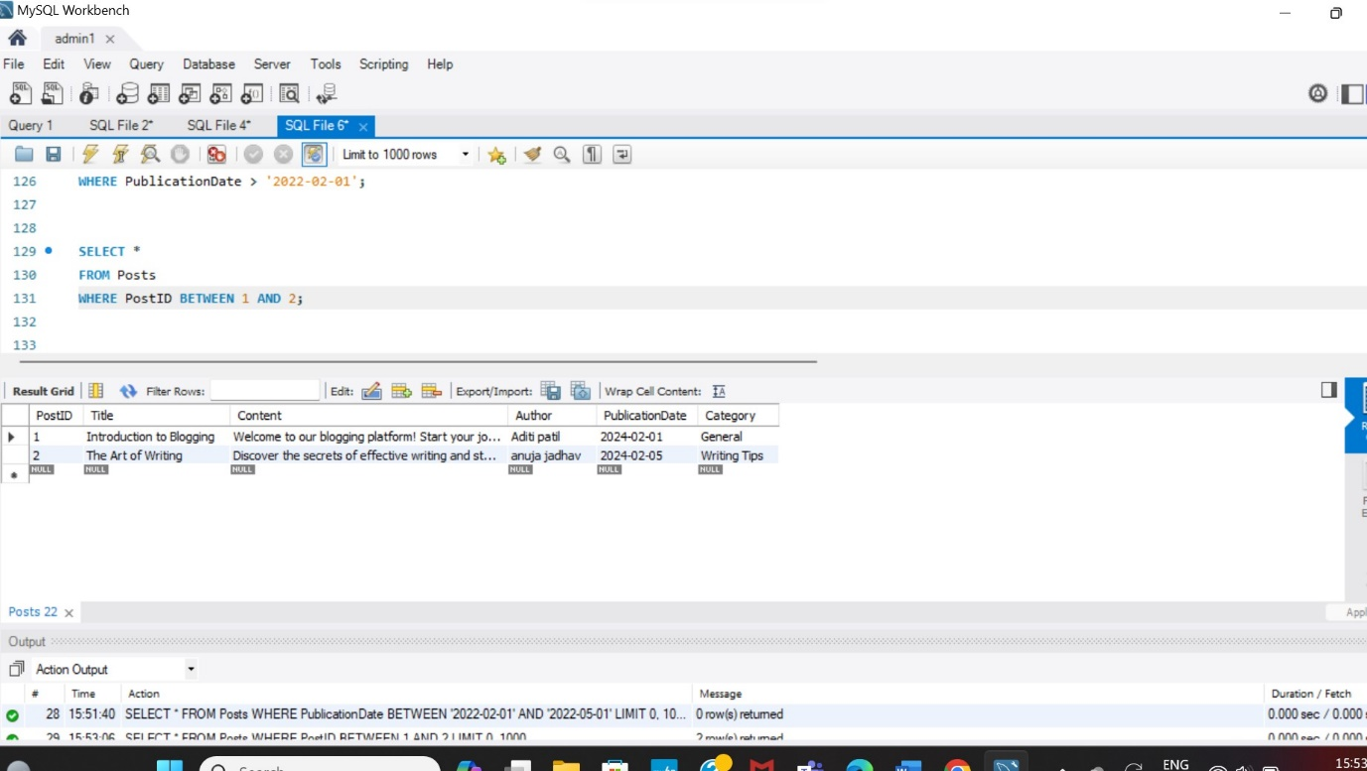

Q.13 How to fetch record which is named by sara khan?

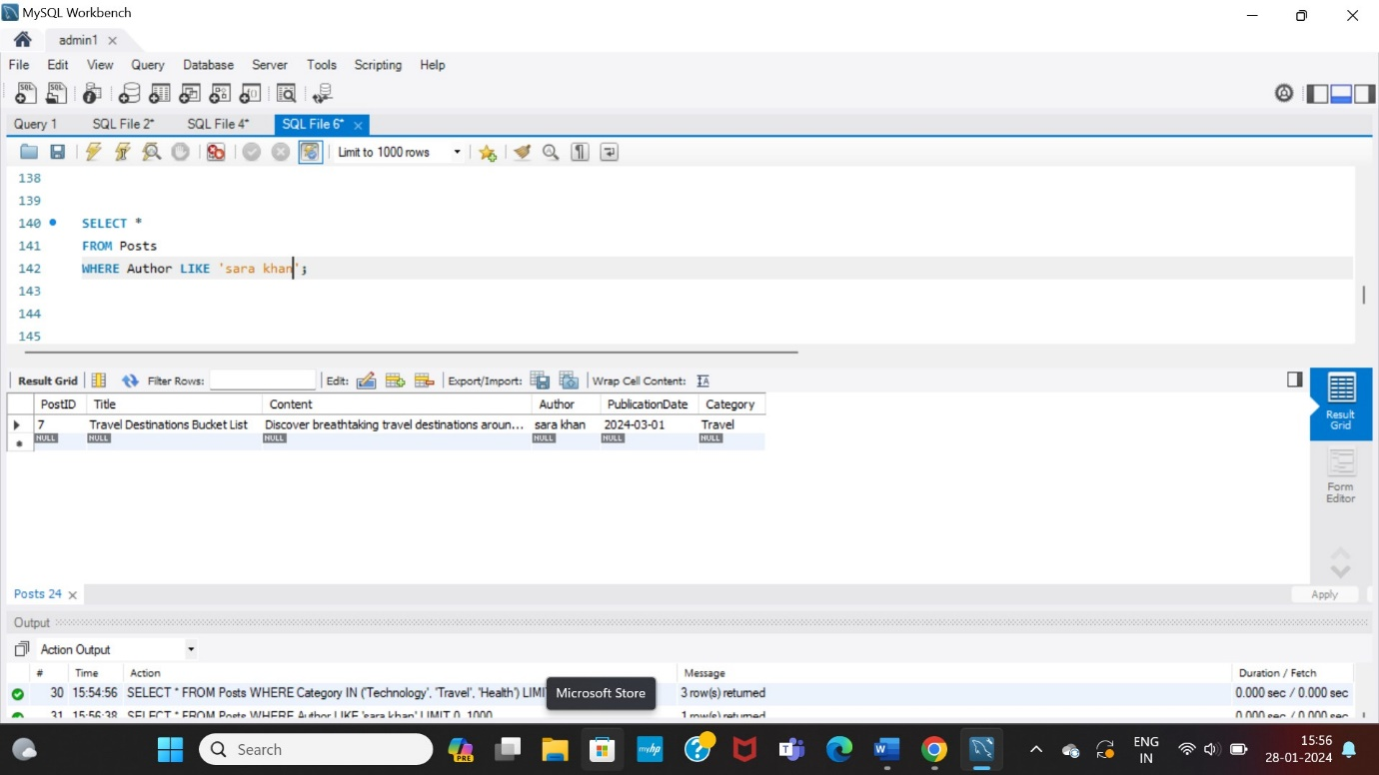

Q.14 How to sort rows data by publication date?

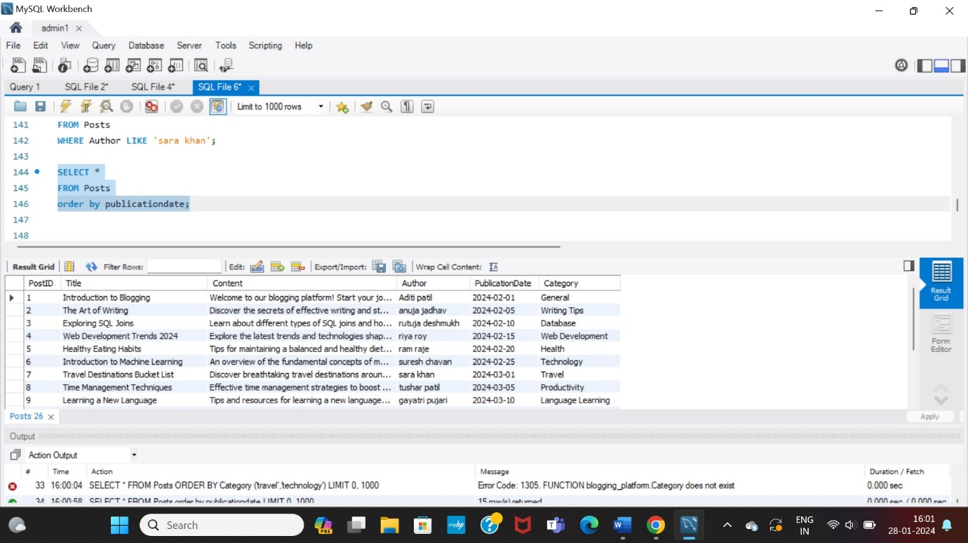

Q.15 How to group data by category and find post count related to that category?

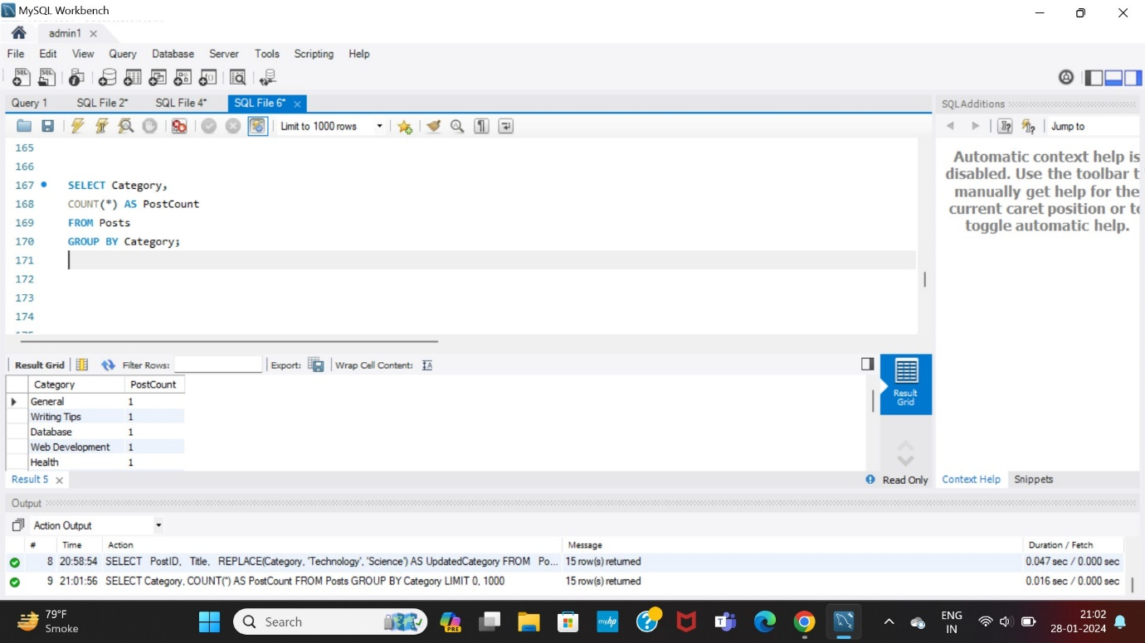

Q.16 How to select single column category and in which unique categories?

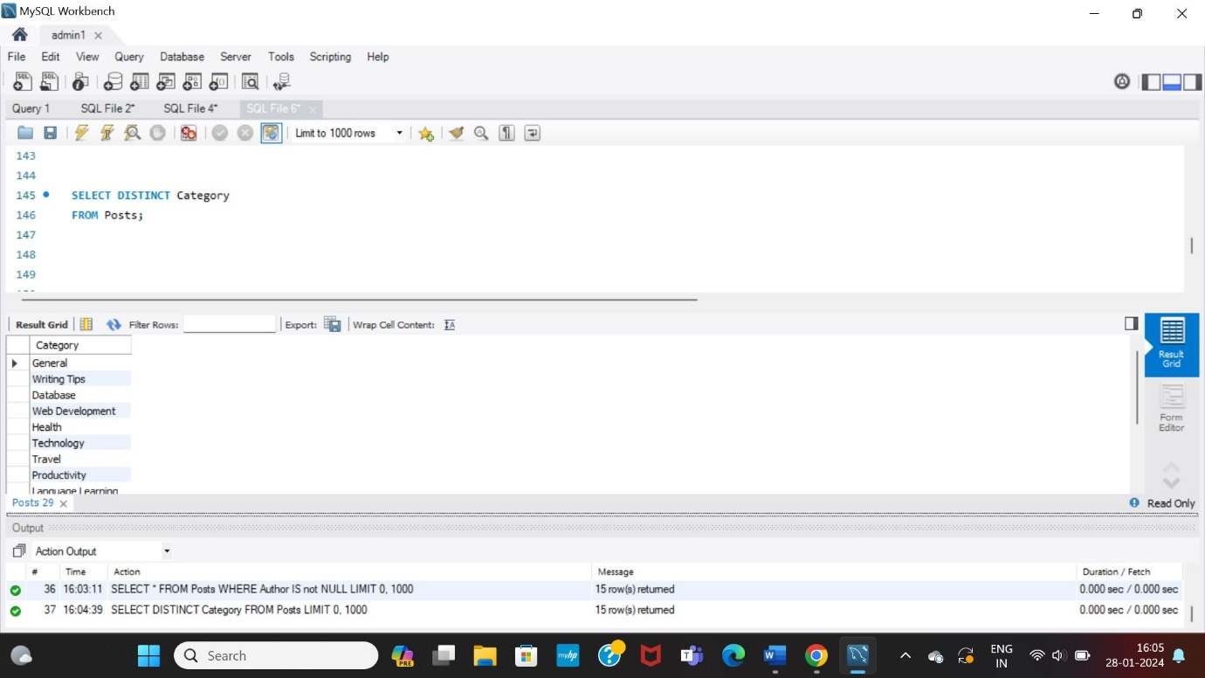

Q.17 How to check if there any null or missing value present in table or not?

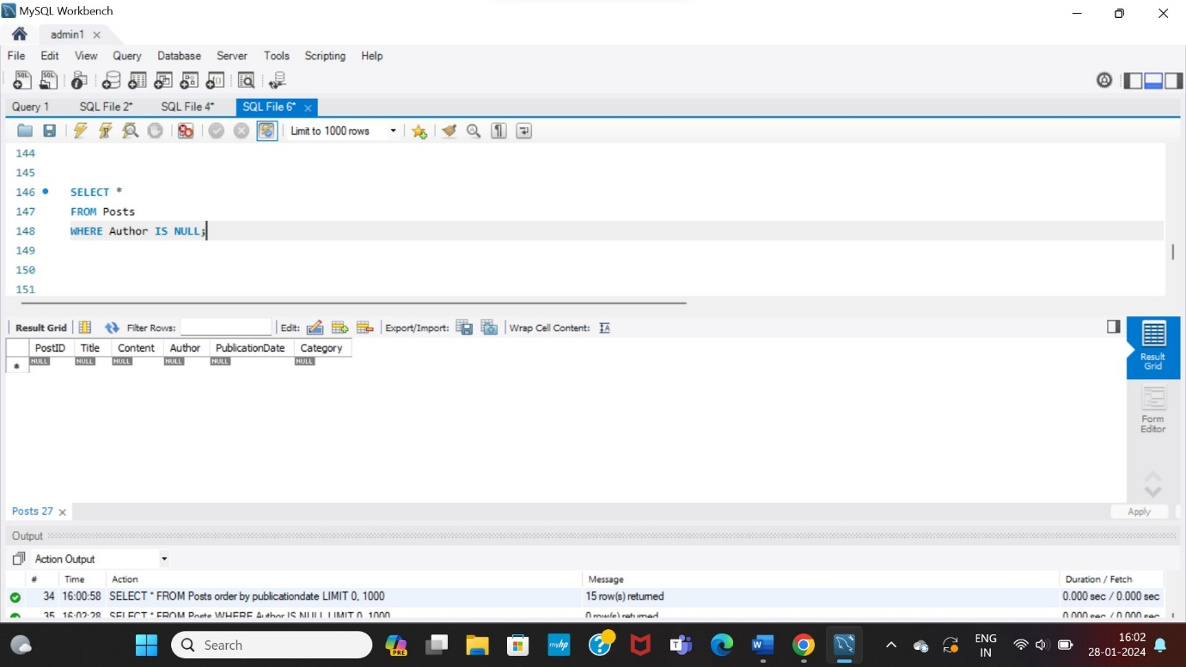

Q.18 How to check not null values in table posts?

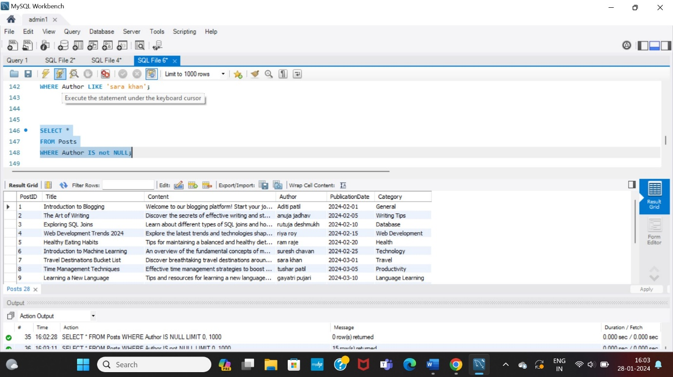

Q.19 How to write name “Aditi Patil” in lower case?

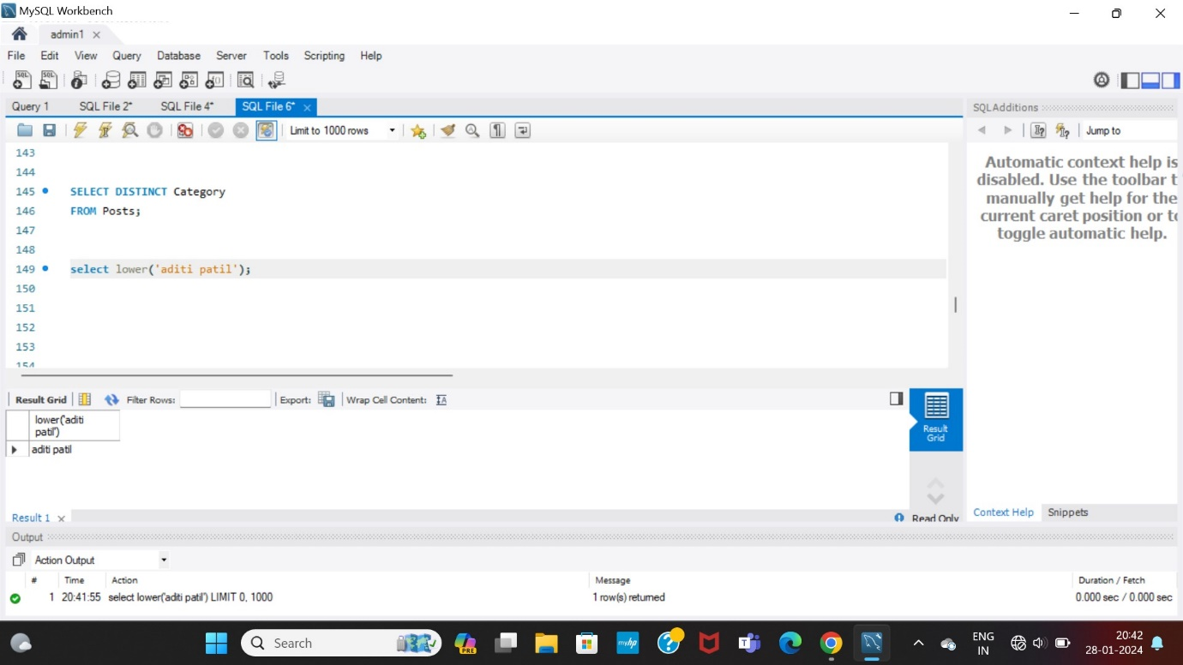

Q.20 How to write name “Aditi Patil” in upper case?

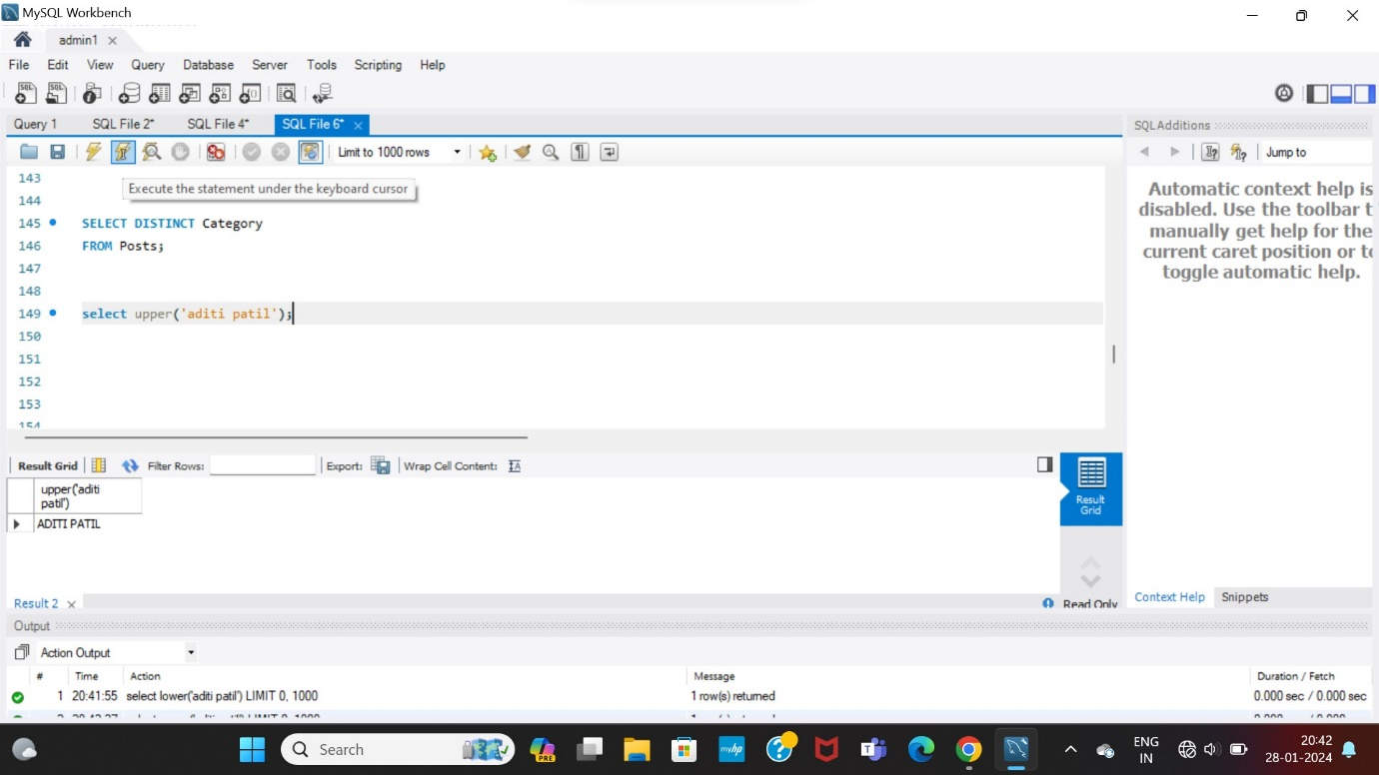

Q.21 How to write “Posts” in reverse format?

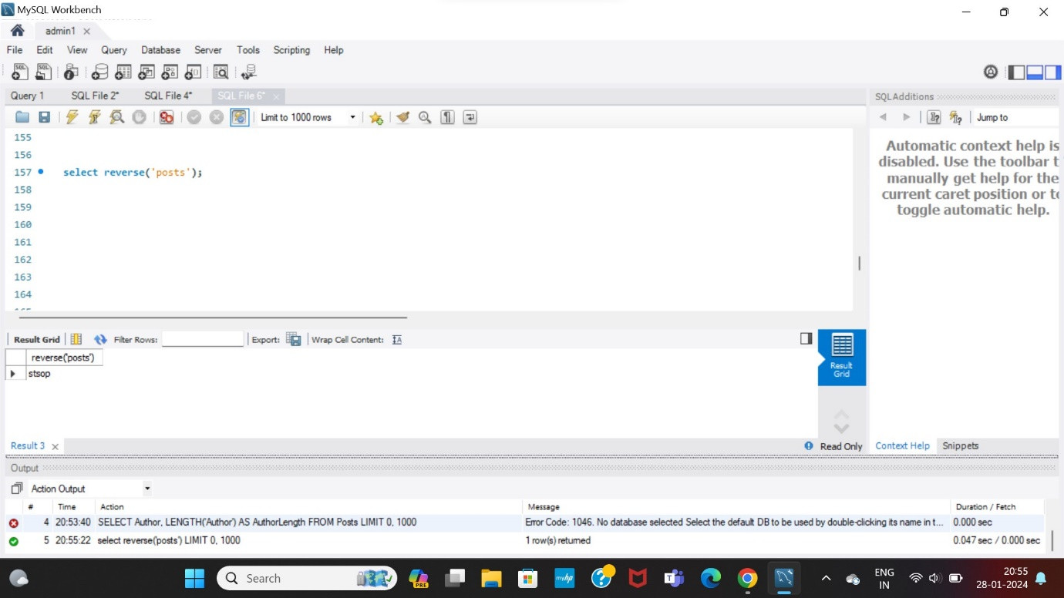

Q.22 How to write or update name of category “technology” as “science”?

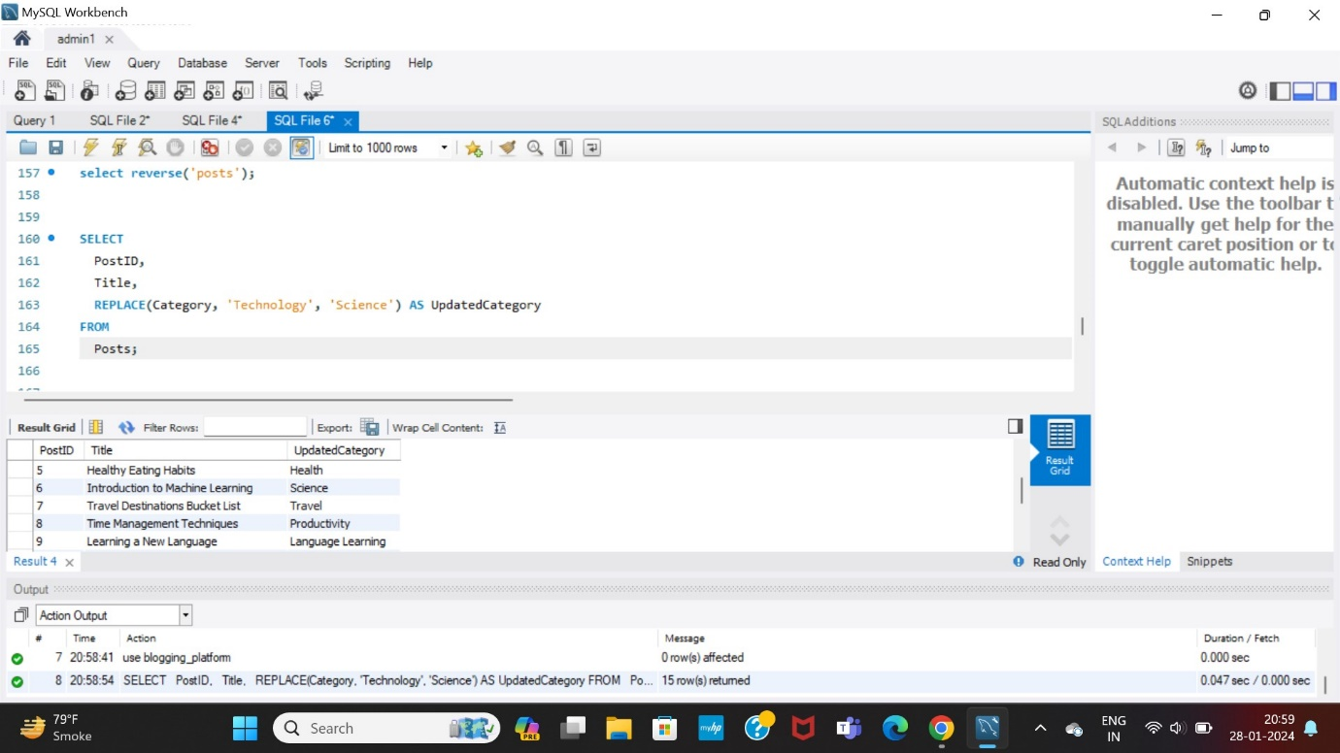

Q.23 How to Concatenate title length by using set and length function?

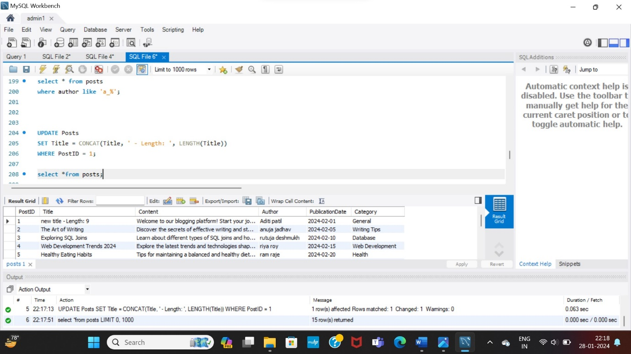

Q.24 How to count total number of posts using count function?

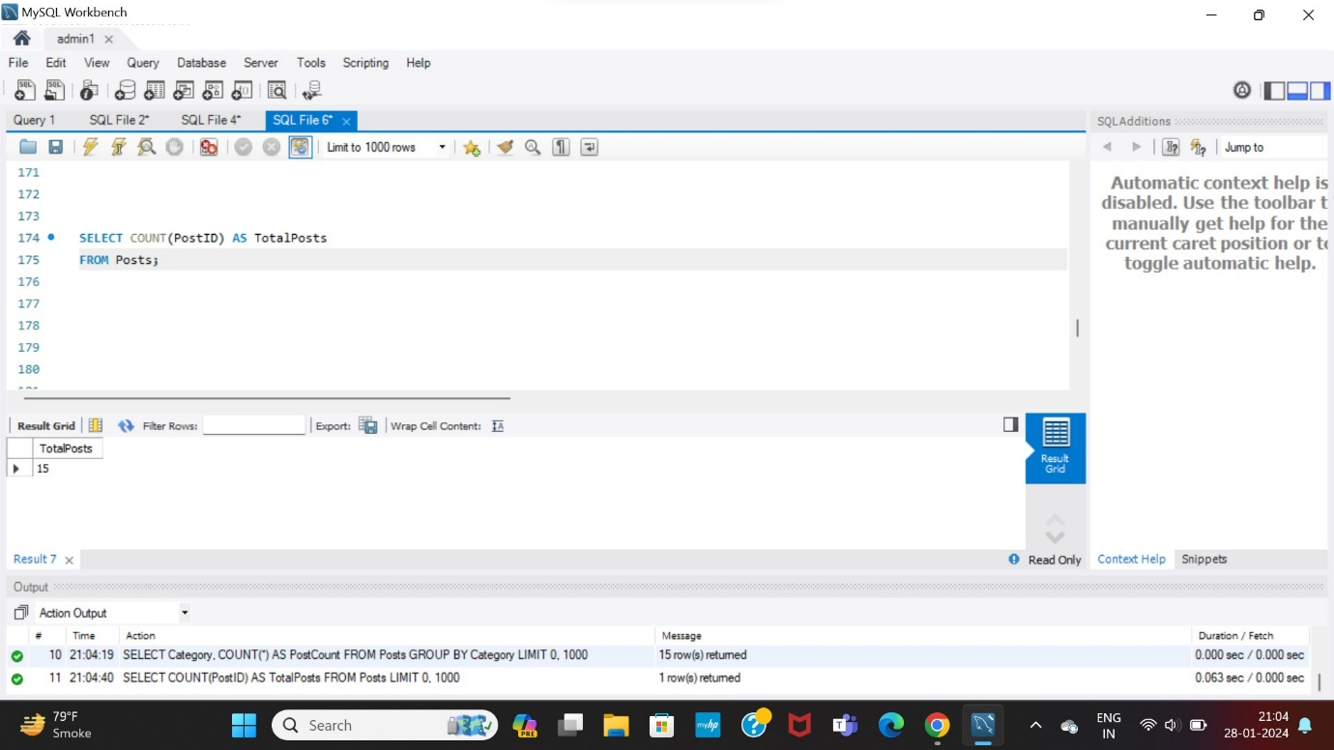

Q.25 How would you retrieve the sum of all values in the PostID column from the Posts table and label the result as SumOfPostID’s?

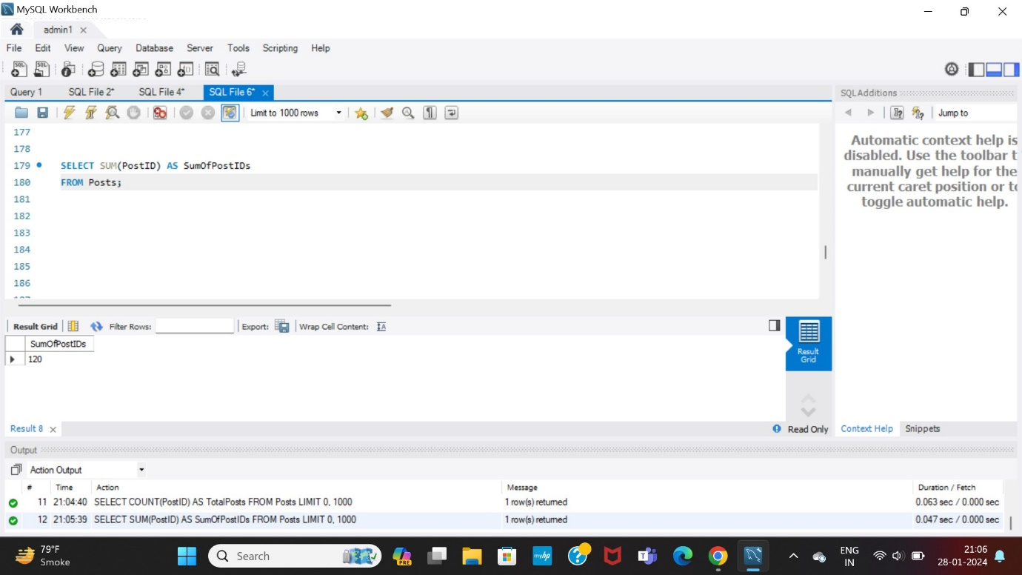

Q.26 What SQL operation calculates the average value of the PostID column in the Posts table and renames the result as AveragePostID?

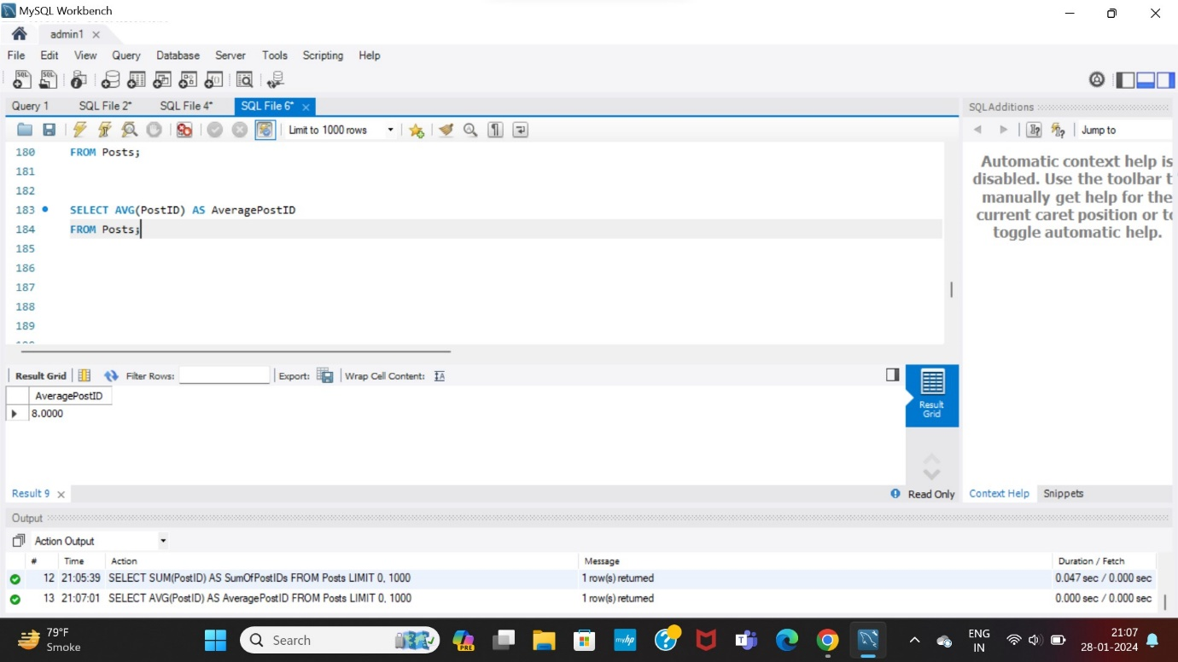

Q.27 How would you retrieve the maximum value of the PostID from the Posts table and rename the result as MaxPostID?

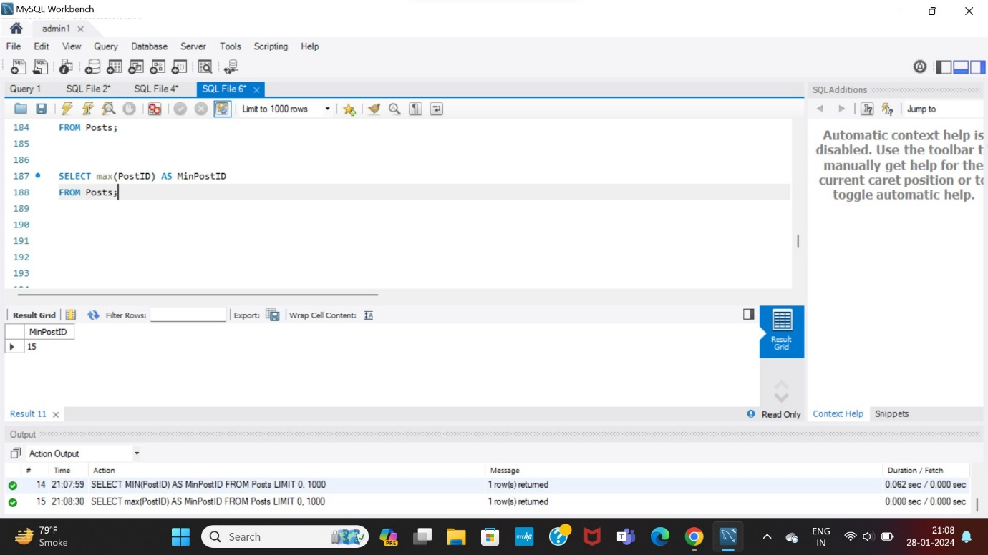

Q.28 How would you retrieve the minimum value of the PostID from the Posts table and rename the result as MaxPostID?

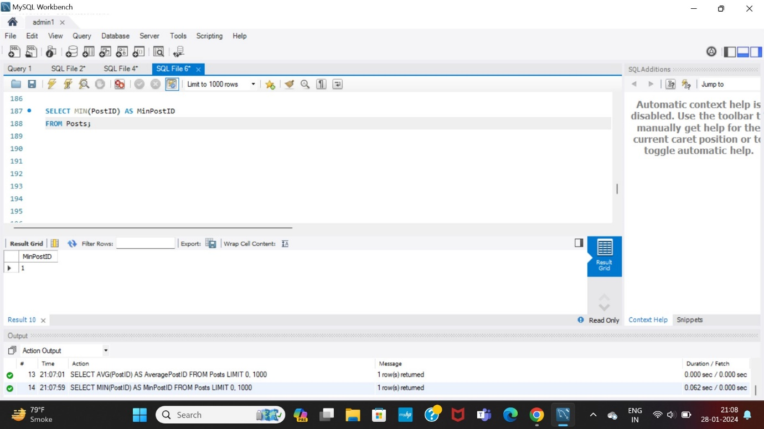

Q.29 How does the CONCAT function enhance the UPDATE statement to modify the Title of a specific post in the Posts table?



Q.30 How would you retrieve data from a table named Posts where the authors' names start with the letter 'A' followed by any character?

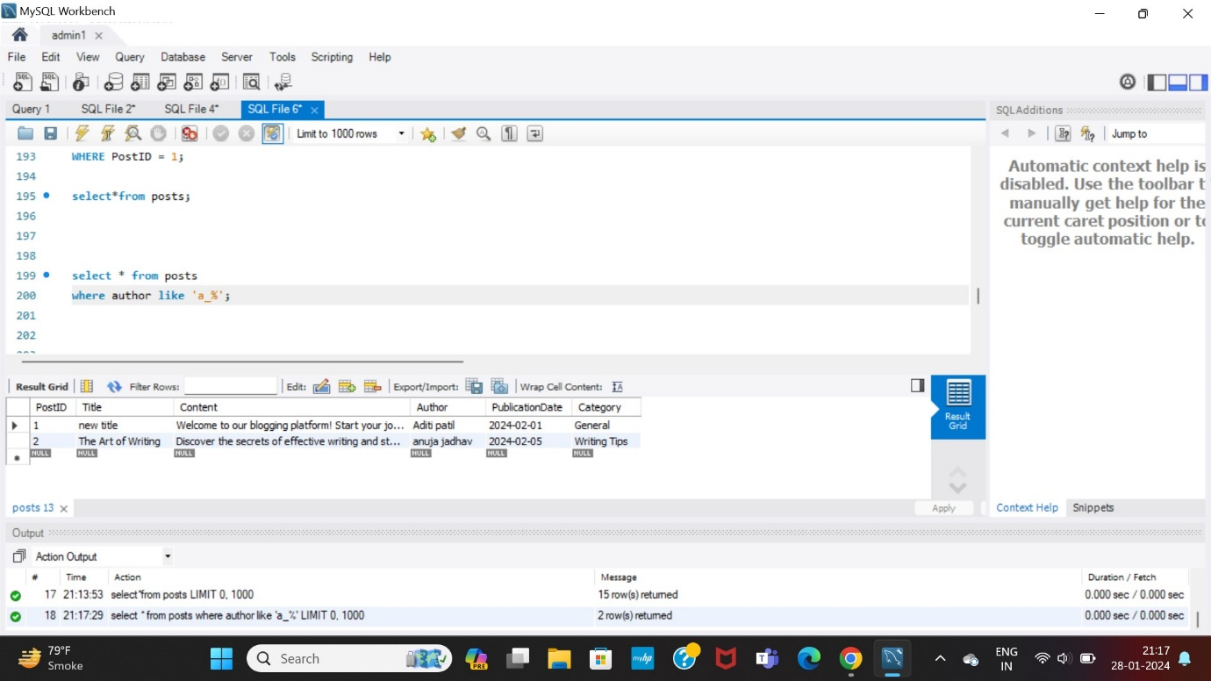

Q.31 How do you use the “GetLength” function in a SQL query?

First defining function for getlength:

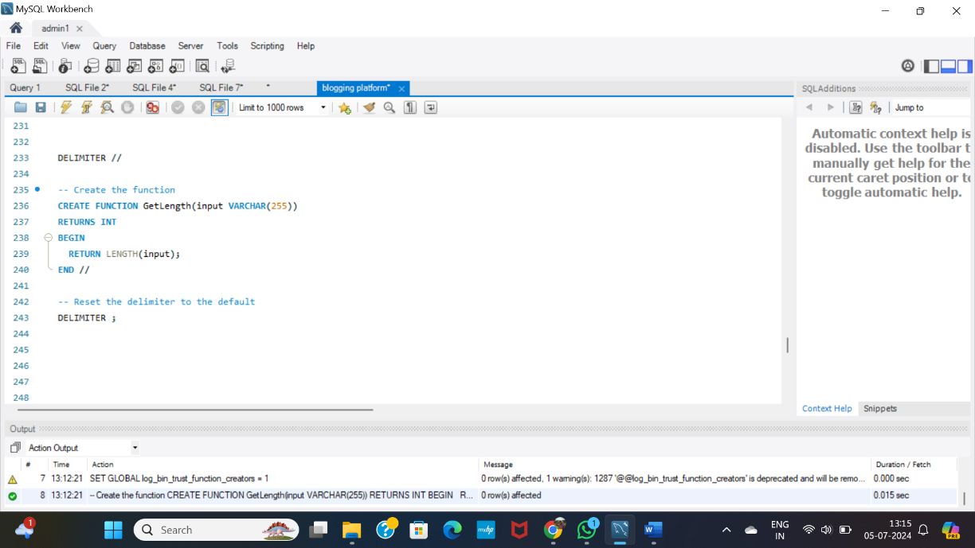

Calling the function:

The “GetLength” function is useful in scenarios where you need to:

Determine the size or length of data stored in VARCHAR fields.

Validate input data lengths against predefined limits.

Perform calculations or comparisons based on the length of strings.

